INDEX

Sl No | Name of the program | Date | Page No | Remarks
1 | Create your class time table using table tag. | 12-01-2026 | 4
2 | Design a web Page for your college containing description of courses, department, faculties, library etc. Using list tags, href tags and anchor tags. | 14-01-2026 | 6
3 | Create Your Resume using HTML .Use text,link and lists. | 16-01-2026 | 9
4 | Create a Web page of a Supermarket using (internal CSS). | 02-02-2026 | 11
5 | Use Inline CSS to format your Resume that you have created. | 04-02-2026 | 13
6 | Use External CSS to format your time table created. | 12-02-2026 | 15
7 | Use all the CSS(Inline,internal and external) to formatbthe college web page that you have created. | 16-02-2026 | 17
8 | Write a HTML Program to create your college website for mobile device. | 25-02-2026 | 20

Program 1
Create class time table using table tag

Aim
Create a html page to display class time table

Program
<!DOCTYPE html>
<html>
<head>
<title> Time Table</title>
</head>
<body>
<table border="3" align="center">
<h2 align="center">BCA Time Table </h2>
<tr>
<th>DAYS </th>
<th> Hour 1</th>
<th> Hour 2 </th>
<th> Hour 3 </th>
<th> Hour 4 </th>
<th> Hour 5 </th>
</tr>
<tr>
<th> Day 1 </th>
<td> Maths </td>
<td> D.S </td>
<td> O.S </td>
<td> Mala/Hind </td>
<td> Web </td>
</tr>
<tr>
<th> Day 2 </th>
<td> Web </td>
<td> O.S </td>
<td> English </td>
<td> Maths </td>
<td> IC </td>
</tr>
<tr>
<th> Day 3 </th>
<td> D.S </td>
<td> Mala/Hind </td>
<td> O.S </td>
<td> IC </td>
<td> English </td>
</tr>
<tr>
<th> Day 4 </th>
<td> Maths </td>
<td> English </td>
<td> Mala/Hind </td>
<td> Web lab </td>
<td> Web lab </td>
</tr>
<tr>
<th> Day 5 </th>
<td> IC </td>
<td> Mala/Hind </td>
<td> O.S </td>
</body>
</html>

Output
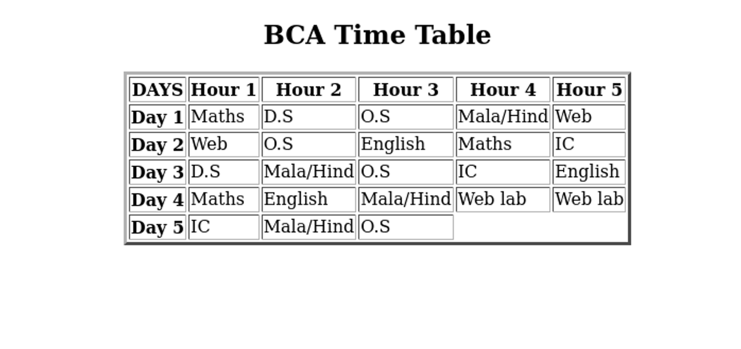

Program 2

Design a web Page for your college containing description of courses, department, faculties, library ect. Using list tags, href tags and anchor tags.

Aim
Design a web Page for your college containing description of courses, department, faculties, library etc. Using list tags, href tags and anchor tags.

Program

<!DOCTYPE html>
<html>
<head>
<title> Webpage </title>
</head>
<h2 align="center"> About </h2>
<p>
St. George's College Aruvithura is a college under Mahatma Gandhi University, Kottayam. It is located in Aruvithura, Erattupetta, Kottayam District in Kerala, India. It was reaccredited with 'A++' Grade by NAAC for seven years in the fourth cycle.

St. George’s College Aruvithura, is a minority educational institution founded by St. George Forane Church, Aruvithura in 1965. Pioneered under the patronage of His Excellency Mar Sebastian Vayalil, the first Bishop of Pala, and cherished by a host of visionaries and philanthropists like Very Rev. Fr. Thomas Araythinal and Mr T. A. Thomman (Former Minister), the college, right from its inception, embarked on an odyssey towards academic pre-eminence. Very Rev. Fr. Thomas Manakkat, the founding manager and a great visionary, was truly instrumental in laying the foundations for a great beginning and Very Rev. Fr. Jacob Thazhathel, who followed him, was equally adept and insightful in his ideals, guiding the college during the early stages of its growth. For more than two decades, His Excellency Mar Joseph Pallickaparampil, the Bishop of Pala, had been the patron of the college. His Excellency Mar Joseph Kallarangattu is the present patron of this seat of learning.

Currently, the college offers 17 undergraduate courses, and 5 postgraduate courses and the Department of Chemistry and Physics are recognized Research Centers under MG University.</p>
<h2> Courses </h2>
<ul>
<li> UG</li>
<li> PG </li>
<li> PhD </li>
<li> Open course </li>
<li> Certificate Course </li>
</ul>
<h2> Departments </h2>
<ul>
<li> Department of Botany and Zoology</li>
<li> Department of Chemistry</li>
<li> Department of Commerce (Aided)</li>
<li> Department of Commerce (SF)</li>
<li> Department of Computer Applications (Aided)</li>
<li>Department of Computer Applications (SF) </li>
<li>Department of Economics</li>
<li> Department of English (Aided)</li>
</ul>
<h2> Faculties </h2>
<ul>
<li><a href=""> Department of Botany and Zoology</a></li>
<li><a href=""> Department of Chemistry</a></li>
<li><a href=""> Department of Commerce (Aided)</a></li>
<li><a href=""> Department of Commerce (SF)</a></li>
<li><a href=""> Department of Computer Applications (Aided)</a></li>
<li><a href="">Department of Computer Applications (SF)</a></li>
<li><a href="">Department of Economics</a></li>
<li><a href=""> Department of English (Aided)</a></li>
</ul>
<li> library </li>
<ul><li><a href="">library</a></li></ul><br>
visit here for more details...<a href="https://sgcaruvithura.ac.in/-index.html">college website</a>
</body>
</html>

Output
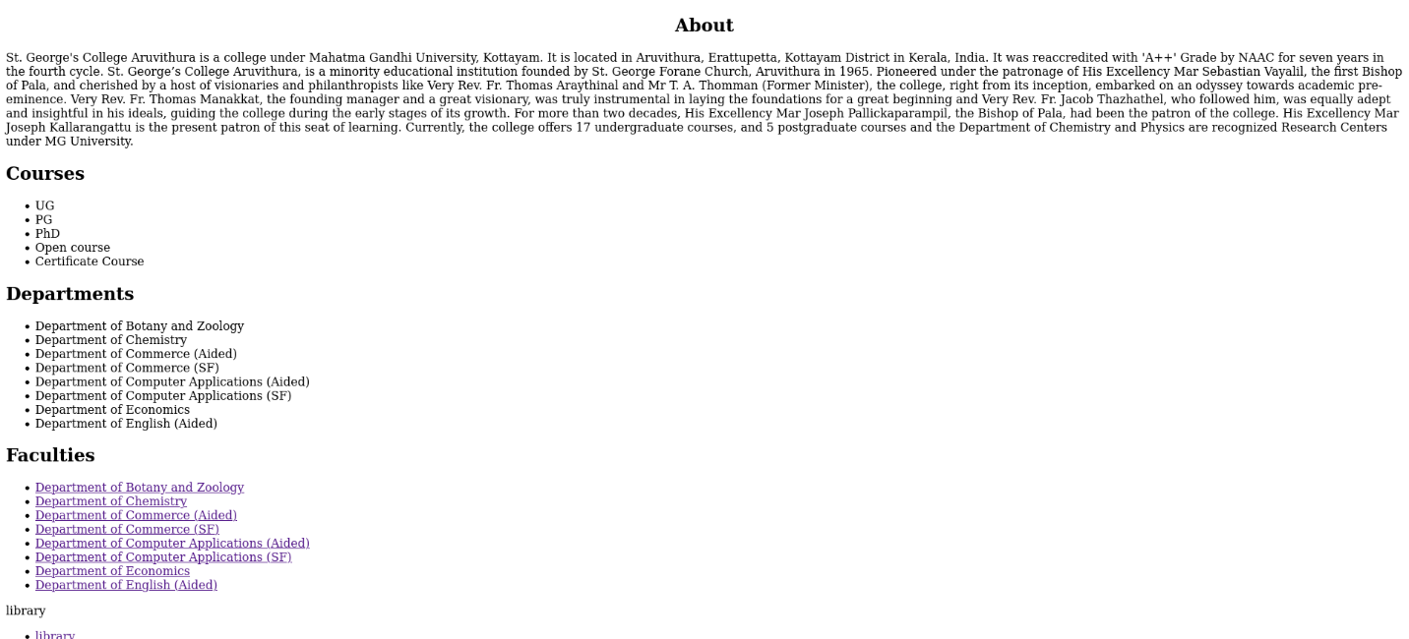

Program 3
Create Your Resume Using HTML.Use text ,link and lists.

Aim
Create your resume using HTML.Use text,link and lists.

Program
<!DOCTYPE html>
<html>
<head>
<title> Resume </title>
</head>
<body>
<h1 align="center"> Resume </h1>
<h2> Personal Information </h2>
Nme: Fifa Mariyam <br>
Date of Birth: 12/05/2007 <br>
E-Mail: fifamariyam075@gmail.com<br>
Register: 2367<br>
Address:Puthupparambil (H) kottayam,keralam<br>
Phone No: 98452367<br>
<h2> Education Qualification </h2>
<ul>
<li> 10 th </li>
school: Muslim Girls Higher Secondary School,Erattupetta<br>
<li> 12 th </li>
school: Muslim Girls Higher Secondary School,Erattupetta<br>
<li> Degree </li>
College: St.George College,Aruvithura<br>
1 st year,2025-2029 Batch
</ul>
<h2> Skills </h2>
<ul>
<li> Programming Languges:C </li>
<li> Web Technology: HTML, CSS </li>
<li> Communication </li>
</ul>
<h2> Acheviments and Certificates </h2>
<ul>
<li> Former JRC Member </li>
<li> CS-50 Project Certificate</li>
</ul>
<h2> Hobbies </h2>
<ul>
<li> Dancing </li>
<li> Reading</li>
<li> Listening Music </li>
</ul>
</body>
</html>

Output


Program 4
Create a Web page of a Supermarket Using (internal CSS).

Aim
Create a web page of a supermarket using (internal CSS).

Program
<!DOCTYPE html>
<html>
<head>
<style>
.fruit{
color:green;
font-size:20px;
}
</style>
<title> Supermarket </title>
</head>
<body>
<h2 align="center"> SUPERMARKET </h2>
<h3 class="fruit"> Fruits </h3>
<ol>
<li> Apple </li>
<li> Orange </li>
<li> Bannana </li>
<ul>
<li> Raw Bannana </li>
<li> Ripe Bannana </li>
</ul>
<li> Kiwi </li>
<li> Avacado </li>
<li> Mango </li>
<ul>
<li> Raw Bannana </li>
<li> Rope Bannana </li>
</ol>
</ul>
<h3 class="fruit"> Rice </h3>
<ol>
<li> Matta Rice </li>
<li> Jeerakasala Rice </li>
<li> Pokkali Rice </li>
<li> Jaya Rice </li>
<li> Ponni Rice </li>
</ol>
<h3 class="fruit"> Vegatables </h3>
<ol>
<li> Carrot </li>
<li> Tomato </li>
<li> Potato </li>
<li> Onion </li>
</ol>
</body>
</html>

Output
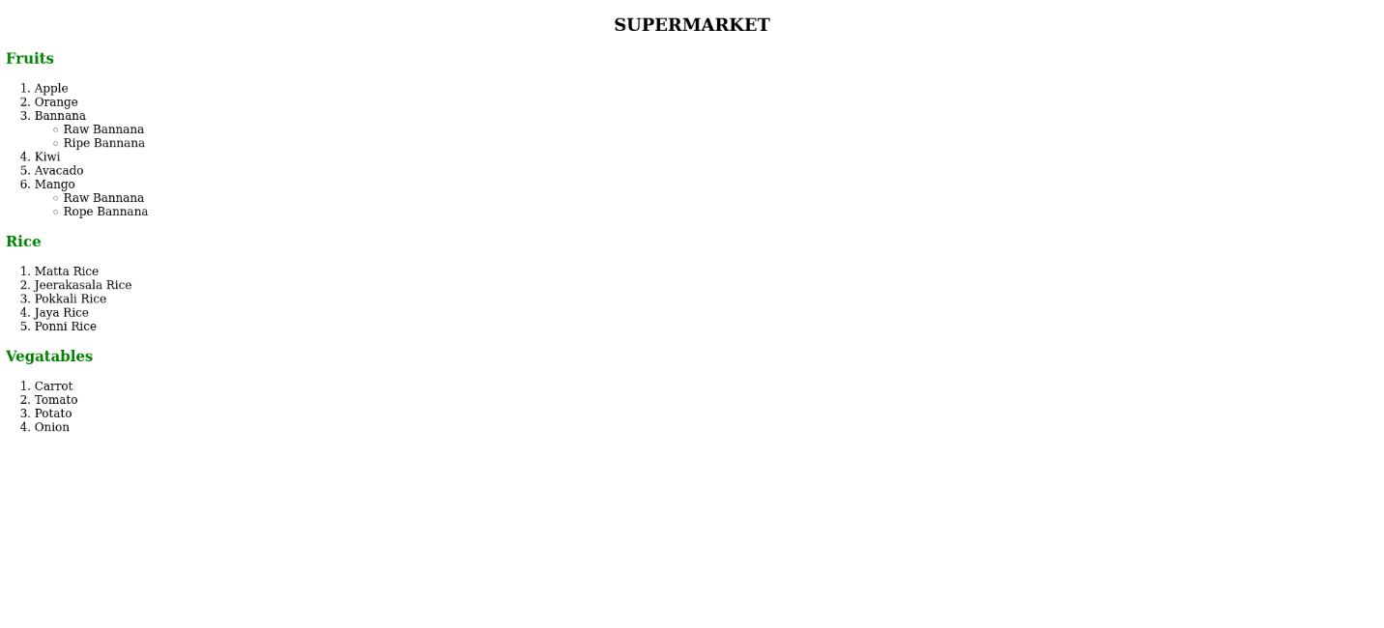

Program 5
Use Inline CSS to format your resume that you have created.

Aim
Use Inline CSS to format your resume that you have created.

Program
<!DOCTYPE html>
<html>
<head>
<title> Resume </title>
</head>
<body>
<h1 align="center"> Resume </h1>
<h3 font-size:"25px;"> Personal Information </h3>
Nme: Fifa Mariyam <br>
Date of Birth: 12/05/2007 <br>
E-Mail: fifamariyam075@gmail.com<br>
Register: 2367<br>
Address:Puthupparambil (H) kottayam,keralam<br>
Phone No: 98452367<br>
<h3 font-size:"25px;"> Education Qualification </h3>
<ul>
<li> 10 th </li>
school: Muslim Girls Higher Secondary School,Erattupetta<br>
<li> 12 th </li>
school: Muslim Girls Higher Secondary School,Erattupetta<br>
<li> Degree </li>
College: St.George College,Aruvithura<br>
1 st year,2025-2029 Batch
</ul>
<h3 font-size:"25px;"> Skills </h3>
<ul>
<li> Programming Languges:C </li>
<li> Web Technology: HTML, CSS </li>
<li> Communication </li>
</ul>
<h3 font-size:"25px;"> Acheviments and Certificates </h3>
<ul>
<li> Former JRC Member </li>
<li> CS-50 Project Certificate</li>
</ul>
<h3 font-size:"25px;"> Hobbies </h3>
<ul>
<li> Dancing </li>
<li> Reading</li>
<li> Listening Music </li>
</ul>
</body>
</html>

Output


Program 6
Use External CSS to format your time table created.

Aim
Use External CSS to format your time table created.

Program
<!DOCTYPE html>
<html>
<head>
<link rel="stylesheet" href="external.css">
<title> Time Table</title>
</head>
<body>
<table border="3" align="center">
<h2 align="center">BCA Time Table </h2>
<tr>
<th>DAYS </th>
<th> Hour 1</th>
<th> Hour 2 </th>
<th> Hour 3 </th>
<th> Hour 4 </th>
<th> Hour 5 </th>
</tr>
<tr>
<th> Day 1 </th>
<td> Maths </td>
<td> D.S </td>
<td> O.S </td>
<td> Mala/Hind </td>
<td> Web </td>
</tr>
<tr>
<th> Day 2 </th>
<td> Web </td>
<td> O.S </td>
<td> English </td>
<td> Maths </td>
<td> IC </td>
</tr>
<tr>
<th> Day 3 </th>
<td> D.S </td>
<td> Mala/Hind </td>
<td> O.S </td>
<td> IC </td>
<td> English </td>
</tr>
<tr>
<th> Day 4 </th>
<td> Maths </td>
<td> English </td>
<td> Mala/Hind </td>
<td> Web lab </td>
<td> Web lab </td>
</tr>
<tr>
<th> Day 5 </th>
<td> IC </td>
<td> Mala/Hind </td>
<td> O.S </td>
</body>
</html>

External.css
table{
color:green;
font-size:25px;
}

Output
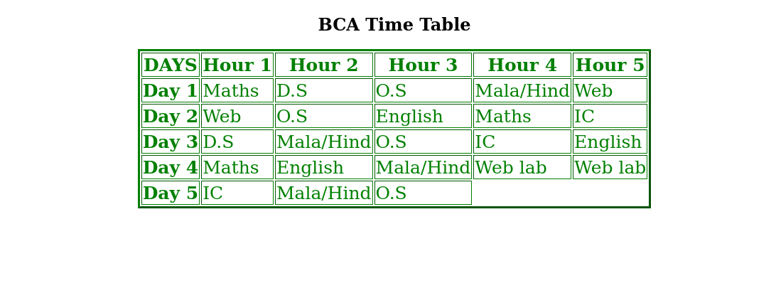

Program 7

Use all the CSS (inline,internal and external) to format the college web page that you have created.

Aim
Use all the CSS(inline,internal and external) to formate the college web page that you have created.

Program
<!DOCTYPE html>
<html>
<head>
<title> Webpage </title>
<style>
p{
font-size:20px;
font-family:sans-serif;
}
</style>
<link rel="stylesheet" href="course.css">
</head>
<h2 align="center"> About </h2>
<p>
St. George's College Aruvithura is a college under Mahatma Gandhi University, Kottayam. It is located in Aruvithura, Erattupetta, Kottayam District in Kerala, India. It was reaccredited with 'A++' Grade by NAAC for seven years in the fourth cycle.

St. George’s College Aruvithura, is a minority educational institution founded by St. George Forane Church, Aruvithura in 1965. Pioneered under the patronage of His Excellency Mar Sebastian Vayalil, the first Bishop of Pala, and cherished by a host of visionaries and philanthropists like Very Rev. Fr. Thomas Araythinal and Mr T. A. Thomman (Former Minister), the college, right from its inception, embarked on an odyssey towards academic pre-eminence. Very Rev. Fr. Thomas Manakkat, the founding manager and a great visionary, was truly instrumental in laying the foundations for a great beginning and Very Rev. Fr. Jacob Thazhathel, who followed him, was equally adept and insightful in his ideals, guiding the college during the early stages of its growth. For more than two decades, His Excellency Mar Joseph Pallickaparampil, the Bishop of Pala, had been the patron of the college. His Excellency Mar Joseph Kallarangattu is the present patron of this seat of learning.

Currently, the college offers 17 undergraduate courses, and 5 postgraduate courses and the Department of Chemistry and Physics are recognized Research Centers under MG University.</p>
<h2 style="font-size:sans-serif;"> Courses </h2>
<ul>
<li> UG</li>
<li> PG </li>
<li> PhD </li>
<li> Open course </li>
<li> Certificate Course </li>
</ul>
<h2> Departments </h2>
<ul>
<li> Department of Botany and Zoology</li>
<li> Department of Chemistry</li>
<li> Department of Commerce (Aided)</li>
<li> Department of Commerce (SF)</li>
<li> Department of Computer Applications (Aided)</li>
<li>Department of Computer Applications (SF) </li>
<li>Department of Economics</li>
<li> Department of English (Aided)</li>
</ul>
<h2> Faculties </h2>
<ul>
<li><a href=""> Department of Botany and Zoology</a></li>
<li><a href=""> Department of Chemistry</a></li>
<li><a href=""> Department of Commerce (Aided)</a></li>
<li><a href=""> Department of Commerce (SF)</a></li>
<li><a href=""> Department of Computer Applications (Aided)</a></li>
<li><a href="">Department of Computer Applications (SF)</a></li>
<li><a href="">Department of Economics</a></li>
<li><a href=""> Department of English (Aided)</a></li>
</ul>
<li> library </li>
<ul><li><a href="">library</a></li></ul><br>
visit here for more details...<a href="https://sgcaruvithura.ac.in/-index.html">college website</a>
</body>
</html>

Course.css
.course{
font-family:sans-serif;
}
a:hover{
color:red;
}

Output
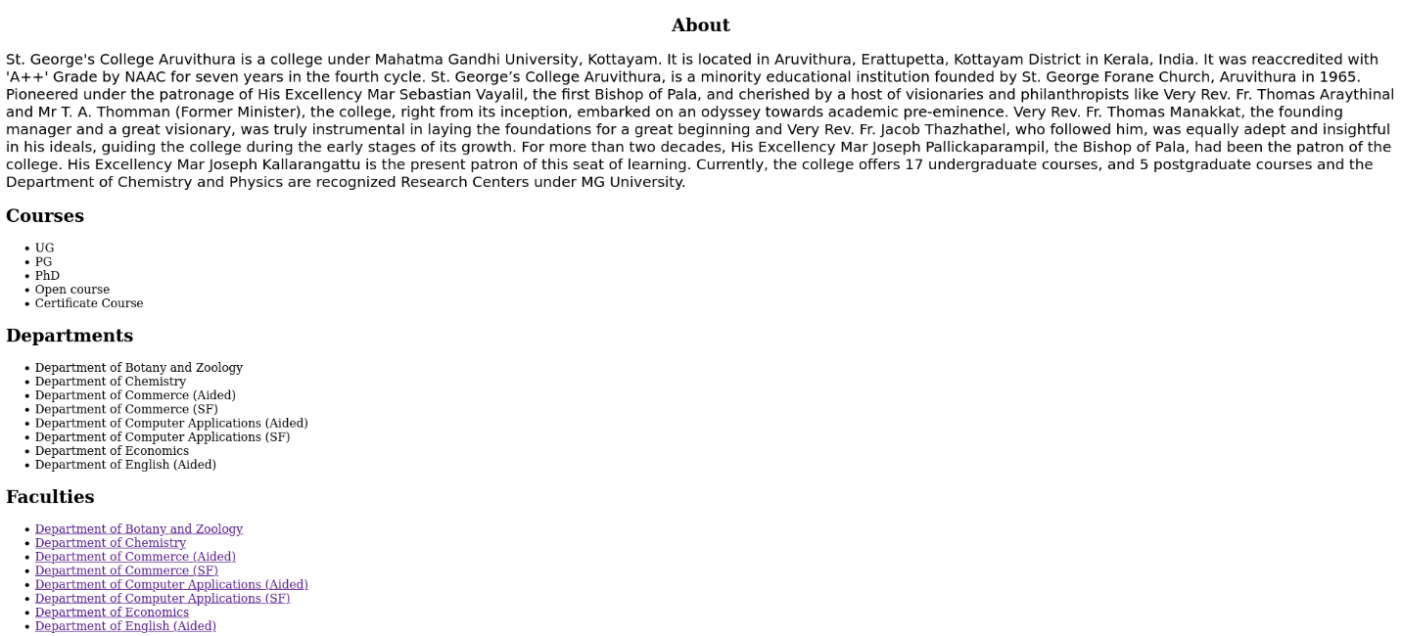

Program 8
Write a HTML Program to create your college website for mobile device.

Aim
Write a HTML Program to create your college website for mobile device.

Program
<!DOCTYPE html>
<html>
<head>
<meta name="viewport" content="width=device-width, initial-scale=1.0">
<title> St.George College Aruvithura</title>
</head>
<body>
<h1 align="center"> St.George College Aruvithura </h1>
<h2 align="center"> About </h2>
<p>
St. George's College Aruvithura is a college under Mahatma Gandhi University, Kottayam. It is located in Aruvithura, Erattupetta, Kottayam District in Kerala, India. It was reaccredited with 'A++' Grade by NAAC for seven years in the fourth cycle.

St. George’s College Aruvithura, is a minority educational institution founded by St. George Forane Church, Aruvithura in 1965. Pioneered under the patronage of His Excellency Mar Sebastian Vayalil, the first Bishop of Pala, and cherished by a host of visionaries and philanthropists like Very Rev. Fr. Thomas Araythinal and Mr T. A. Thomman (Former Minister), the college, right from its inception, embarked on an odyssey towards academic pre-eminence. Very Rev. Fr. Thomas Manakkat, the founding manager and a great visionary, was truly instrumental in laying the foundations for a great beginning and Very Rev. Fr. Jacob Thazhathel, who followed him, was equally adept and insightful in his ideals, guiding the college during the early stages of its growth. For more than two decades, His Excellency Mar Joseph Pallickaparampil, the Bishop of Pala, had been the patron of the college. His Excellency Mar Joseph Kallarangattu is the present patron of this seat of learning.

Currently, the college offers 17 undergraduate courses, and 5 postgraduate courses and the Department of Chemistry and Physics are recognized Research Centers under MG University.</p>
<h2> Courses </h2>
<ul>
<li> UG</li>
<li> PG </li>
<li> PhD </li>
<li> Open course </li>
<li> Certificate Course </li>
</ul>
<h2> Departments </h2>
<ul>
<li> Department of Botany and Zoology</li>
<li> Department of Chemistry</li>
<li> Department of Commerce (Aided)</li>
<li> Department of Commerce (SF)</li>
<li> Department of Computer Applications (Aided)</li>
<li>Department of Computer Applications (SF) </li>
<li>Department of Economics</li>
<li> Department of English (Aided)</li>
</ul>
<h2> Faculties </h2>
<ul>
<li><a href=""> Department of Botany and Zoology</a></li>
<li><a href=""> Department of Chemistry</a></li>
<li><a href=""> Department of Commerce (Aided)</a></li>
<li><a href=""> Department of Commerce (SF)</a></li>
<li><a href=""> Department of Computer Applications (Aided)</a></li>
<li><a href="">Department of Computer Applications (SF)</a></li>
<li><a href="">Department of Economics</a></li>
<li><a href=""> Department of English (Aided)</a></li>
</ul>
<li> library </li>
<ul><li><a href="">library</a></li></ul><br>
visit here for more details...<a href="https://sgcaruvithura.ac.in/-index.html">college website</a>
</body>
</html>

Output
